**B.M.S. COLLEGE OF ENGINEERING BENGALURU**

Autonomous Institute, Affiliated to VTU



OOMD Mini Project Report

**“Telemedicine Access For Rural**

**HealthCare in Nabha”**

*Submitted in partial fulfillment for the award of degree of*

Bachelor of Engineering

in

Computer Science and Engineering

*Submitted by:*

**Milan Paudel 1BM23CS191**

**Manojkumar 1BM23CS185**

**Makadia Rishit Dilipbhai 1BM23CS177**

**Mohammed Sulayman 1BM23CS197**

**Mohammed Abdul Rehman Faadh Y 1BM23CS193**

Department of Computer Science and Engineering

B.M.S. College of Engineering

Bull Temple Road, Basavanagudi, Bangalore 560 019

2025-26

**B.M.S. COLLEGE OF ENGINEERING**

**DEPARTMENT OF COMPUTER SCIENCE AND ENGINEERING**



***DECLARATION***

We, **Milan Paudel (1BM23CS191), Manojkumar (1BM23CS185), Makadia Rishit Dilipbhai (1BM23CS177), Mohammed Sulayman (1BM23CS197), Mohammed Abdul Rehman Faadh Y (1BM23CS193)** students of 5th Semester, B.E, Department of Computer Science and Engineering, BMS College of Engineering, Bangalore, hereby declare that, this OOMD Mini Project entitled **“Telemedicine Access For Rural HealthCare in Nabha”** has been carried out in Department of CSE, B.M.S. College of Engineering, Bangalore during the academic semester August 2025- December 2025. I also declare that to the best of our knowledge and belief, the OOMD mini Project report is not from part of any other report by any other students.

**Signature of the Candidate**

**Milan Paudel (1BM23CS191)**

**Manoj Kumar (1BM23CS185)**

**Makadia Rishit Dilipbhai (1BM23CS177)**

**Mohammed Sulayman (1BM23CS197)**

**Mohammed Abdul Rehman Faadh Y (1BM23CS193)**

**B.M.S. COLLEGE OF ENGINEERING**

**DEPARTMENT OF COMPUTER SCIENCE AND ENGINEERING**



***CERTIFICATE***

This is to certify that the OOMD Mini Project titled **“Telemedicine Access For Rural HealthCare in Nabha”** has been carried out by Milan Paudel (1BM23CS191), Manoj Kumar (1BM23CS185), Makadia Rishit Dilipbhai (1BM23CS177), Mohammed Sulayman (1BM23CS197), Mohammed Abdul Rehman Faadh Y (1BM23CS193) during the academic year 2025-2026.

Signature of the Faculty in Charge

## Sheetal V A

Assistant Professor

Department of Computer Science and Engineering

B.M.S. College of Engineering, Bangalore

**Table of Contents**

| **Sl No.** | **Title** | **Page No.** |
| --- | --- | --- |
| 1 | Ch 1: Problem statement | 3 |
| 2 | Ch 2: Software Requirement Specification | 6 |
| 3 | Ch 3: Class Diagram | 11 |
| 4 | Ch 4: State Diagram | 13 |
| 5 | Ch 5: Interaction diagram | 15 |
| 6 | Ch 6: UI Design with Screenshots | 20 |

**Chapter 1:** Problem Statement

**Problem Statement ID:** SIH25018  
**Problem Statement Title:** "Telemedicine Access For Rural HealthCare in Nabha"

**1.1 The Core Problem**

Rural populations in regions like Nabha face a critical shortage of accessible and affordable specialist healthcare. The primary barriers include:

* Unavailability of Specialist Doctors: A significant deficit of specialist medical professionals in rural Community Health Centres (CHCs).
* High Patient Burden: The necessity for patients to travel long distances to urban centers for consultations, resulting in substantial travel costs, loss of daily wages, and time consumption.
* Digital and Literacy Divide: A large segment of the rural population is not proficient in using smartphones or digital services, preventing them from accessing existing telemedicine solutions.

**1.2 Proposed Solution**

The development of "GramSetu," an AI-powered telemedicine platform designed to bridge this gap. The solution leverages a multi-faceted approach:

* ASHA-Centric Model: Empowers existing ASHA workers to act as tech-enabled facilitators, registering patients and assisting in consultations.
* Offline-First AI Scribe: Utilizes on-device speech recognition (Vosk) to capture patient symptoms in local languages (Hindi/Punjabi) without an internet connection, generating structured clinical summaries for doctors.
* Seamless Doctor Connection: Provides a dedicated dashboard for urban doctors to review AI summaries, conduct secure video consultations (via WebRTC), and issue digital prescriptions.

This solution directly addresses the challenges of distance, cost, and digital literacy, making specialist healthcare a tangible reality for rural India.

**Chapter 2:** Software Requirement Specification

## Telemedicine Consultation System

## 1. Introduction

### 1.1 Purpose of this Document

This document outlines the Software Requirement Specification for the Telemedicine Consultation System designed for rural healthcare access. It describes in detail how the system should behave, the features it will support, the workflows of various users, and the constraints under which it must operate. The intention is to ensure that all stakeholders share a uniform understanding of the system’s objectives and functionalities before development begins.

### 1.2 Scope of this Document

The system aims to streamline the complete lifecycle of a telemedicine consultation from the patient’s arrival at a telemedicine center, to case creation, doctor consultation, prescription generation, and dispensing of medicines. The scope also includes patient registration, appointment scheduling, report uploads, doctor dashboards, pharmacist verification, and administrator activities.

### 1.3 Overview

The Telemedicine Consultation System functions as a multi-user healthcare platform. A patient arrives at a telemedicine center where a community health worker records vitals and initiates a teleconsultation. The system notifies a doctor, provides them with all case details, and enables a secure video consultation. After reviewing the case, the doctor issues a digital prescription that is shared with both the patient and the pharmacist. Medicines are then dispensed accordingly.  
 The system ensures a coordinated, step-by-step medical experience for rural patients while minimizing travel and wait times.

## 2. General Description

The system supports five major user groups: patients, community health workers, doctors, pharmacists, and administrators. Each group interacts with the system through dedicated modules. The patient receives assistance from the CHW, who enters initial information and initiates calls. Doctors operate through a structured dashboard where they review cases, conduct consultations, and generate prescriptions. Pharmacists verify and dispense medicines digitally, and administrators oversee schedules, system maintenance, and usage reports.

The system has been designed with rural limitations in mind. Interfaces are simple, instructions are clear, and the system supports essential workflows even with inconsistent network connectivity. The architecture ensures smooth transitions between online and offline operations wherever applicable.

## 3. Functional Requirements

### 3.1 Patient Module

* Register or log in to the system.
* View upcoming and past appointments.
* Join scheduled video consultations.
* Upload medical reports.
* Access digital prescriptions.
* Provide feedback after consultations.

### 3.2 Community Health Worker Module

* Verify and register patient details upon arrival.
* Record initial vitals and symptoms.
* Initiate telemedicine call with doctor.
* Assist patient during consultation when required.

### 3.3 Appointment and Case Management

* Allow scheduling based on doctor availability.
* Create a case automatically when the CHW initiates a session.
* Notify the doctor of new cases or appointments.
* Support appointment cancellation and rescheduling.

### 3.4 Doctor Module

* Review patient case and uploaded medical documents.
* Conduct video consultations.
* Request laboratory tests if needed.
* Generate and submit digital prescriptions.
* Update patient records after consultation.

### 3.5 Teleconsultation Module

* Securely connect doctor and patient via video session.
* Provide real-time access to patient history.
* Support audio/video quality adjustments based on bandwidth.
* Log consultation details for future reference.

### 3.6 Prescription and Pharmacy Module

* Notify pharmacist whenever a new prescription is issued.
* Allow pharmacist to view, verify, and dispense medicines.
* Update system records after dispensing.

### 3.7 Admin Module

* Manage doctor schedules and availability.
* Add or remove system users.
* Access usage logs and generate administrative reports.

## 4. Interface Requirements

### 4.1 User Interface

* Simple, clean interface for patients and CHWs with minimal steps.
* Web-based dashboard for doctors, pharmacists, and admins.
* Mobile-optimized screens for rural telemedicine centers.
* Local language support depending on region.

### 4.2 Integration Interfaces

* Secure WebRTC-based video conferencing integration.
* Support for uploading and storing medical documents.
* Optional future integration with government health systems.

## 5. Performance Requirements

* The system should respond to basic actions such as loading records or booking appointments within 2–3 seconds.
* Video consultations should adapt to varying network strength through automatic bitrate adjustments.
* The backend should support multiple simultaneous consultations from different centers without performance degradation.
* Patient data synchronization must occur reliably whenever network connectivity is restored.

## 6. Design Constraints

* Must operate efficiently on low-end smartphones commonly used by CHWs.
* Should function in low-bandwidth environments.
* Must use a relational database (e.g., PostgreSQL) to maintain structured records.
* Should comply with standard software design practices suitable for UML modeling.

## 7. Non-Functional Attributes

### 7.1 Security

* Mandatory authentication for all users.
* Encrypted storage of patient data, prescriptions, and medical records.

### 7.2 Reliability

* The system should maintain high availability, with minimal downtime.
* Recovery measures must exist to restore interrupted sessions.

### 7.3 Scalability

* Capable of supporting additional telemedicine centers without architectural changes.

### 7.4 Usability

* Interfaces must be easy to understand for users with limited digital experience.

### 7.5 Portability

* Compatible with Android devices and major web browsers.

### 7.6 Compatibility

* Must work smoothly across Chrome, Firefox, Edge, and Safari.

### 7.7 Data Integrity

* Ensure consistency of records during case creation, prescription generation, and pharmacy updates.

## 8. Preliminary Schedule and Budget

The project will be executed over a 6-month timeline with key phases including requirements analysis, system design, core development with AI integration, and comprehensive testing. A pilot deployment will be conducted in the final phase to validate system performance in real-world rural healthcare scenarios.

Project Timeline: 6 Months

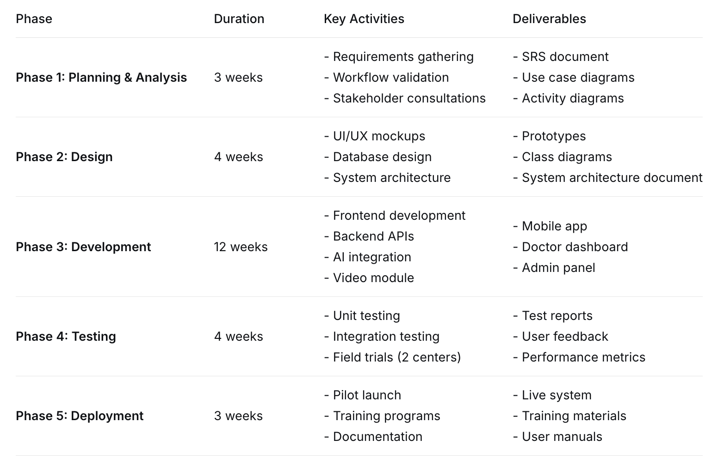

Table 1: Project Timeline and Phase-wise Deliverables

**Chapter 3:** Class Modeling

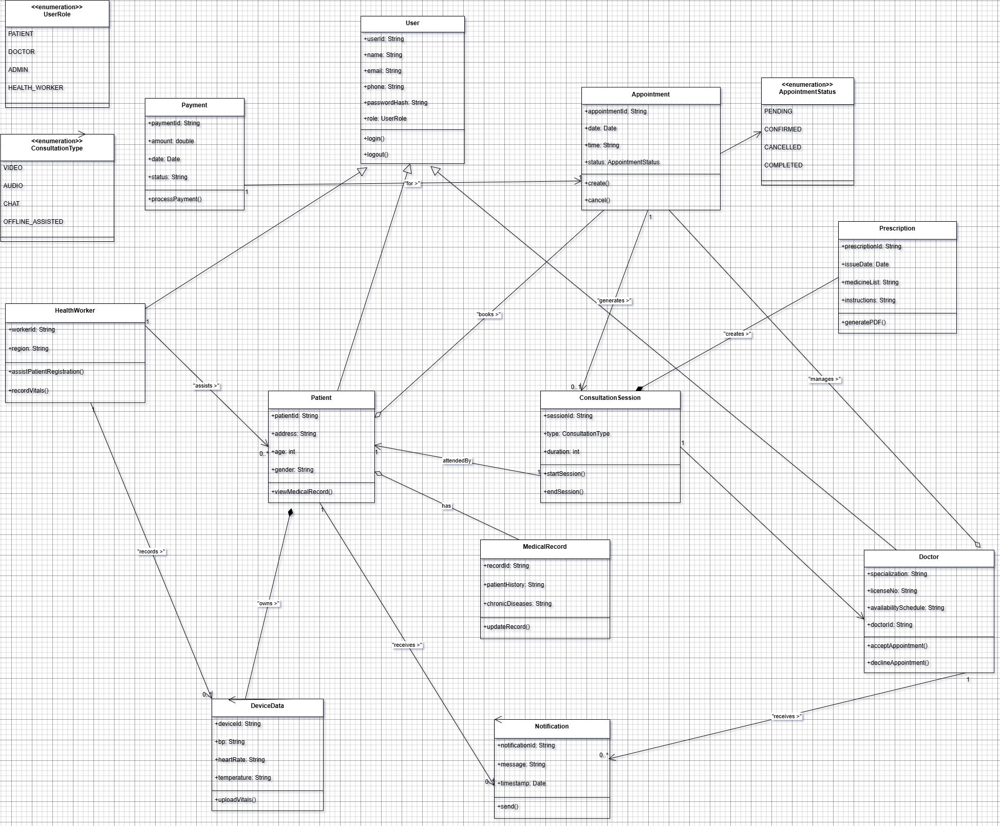

**Class Specifications and Relationships** **Core Entity Classes:**

**User (Abstract Base Class)** Relevance: Central identity management with common attributes  
 Key Attributes: userId, name, role (UserRole enum)  
 Advanced Feature: Abstract class enabling polymorphic behavior

**Patient** Relevance: Manages beneficiary demographic and medical data  
 Key Attributes: address, age, gender for personalized care  
 Relationships: Inherits from User, associates with Appointment

**HealthWorker** Relevance: Digital facilitator for community healthcare delivery  
 Key Attributes: workerId, region for geographical assignment  
 Methods: assistPatientRegistration() for bridge functionality

**Appointment** Relevance: Core scheduling entity managing consultation lifecycle  
 Key Attributes: date, time, status (AppointmentStatus enum)  
 Methods: create(), cancel() for appointment management

**ConsultationSession** Relevance: Manages active medical interaction sessions  
 Key Attributes: type (ConsultationType enum), duration  
 Methods: startSession(), endSession() for session control

**Payment** Relevance: Handles financial transactions for services  
 Key Attributes: amount, status, date  
 Methods: processPayment() for transaction execution

**Advanced Design Features** **Enumeration Types:** UserRole: PATIENT, DOCTOR, ADMIN, HEALTH_WORKER (role-based access control)  
 ConsultationType: VIDEO, AUDIO, CHAT, OFFLINE_ASSISTED (multi-modal consultations)

**Inheritance Hierarchy:** User superclass with specialized subclasses (Patient, HealthWorker)  
 Enables code reusability and polymorphic processing

**Encapsulation:** Private attributes (-) with controlled access methods  
 Data integrity through access modifiers

**Modular Design:** Separation of concerns between identity, scheduling, and session management  
 Extensible architecture for future enhancements

**Chapter 4:** State Modeling

**State Relevance and Transitions** The diagram models the lifecycle of a medical appointment through five distinct states:

1. **Scheduled State** Relevance: Initial confirmed state where appointment details are established  
    Entry Action: System sends confirmation notifications  
    Exit Event: Patient arrival or cancellation request
2. **Active State** Relevance: Live consultation state where medical interaction occurs  
    Entry Action: Video connection established, medical records loaded  
    Exit Event: Consultation completion or technical disruption
3. **Paused State** Relevance: Temporary interruption during consultation  
    Entry Action: Session timer paused, connection maintained  
    Exit Event: Resumption command or timeout
4. **Completed State** Relevance: Successful consultation conclusion  
    Entry Action: Generate prescription, update medical records  
    Exit Event: System archival process
5. **Cancelled State** Relevance: Terminated appointment  
    Entry Action: Notify all parties, free up resources  
    Exit Event: System cleanup procedure

**Advanced Features** Guard Conditions:  
 [Within 24 hours] for cancellation eligibility  
 [Stable connection] for session activation  
 [Payment verified] for appointment confirmation

Composite States:  
 Consultation Session superstate containing Active and Paused substates  
 Terminal States grouping Completed and Cancelled as final states

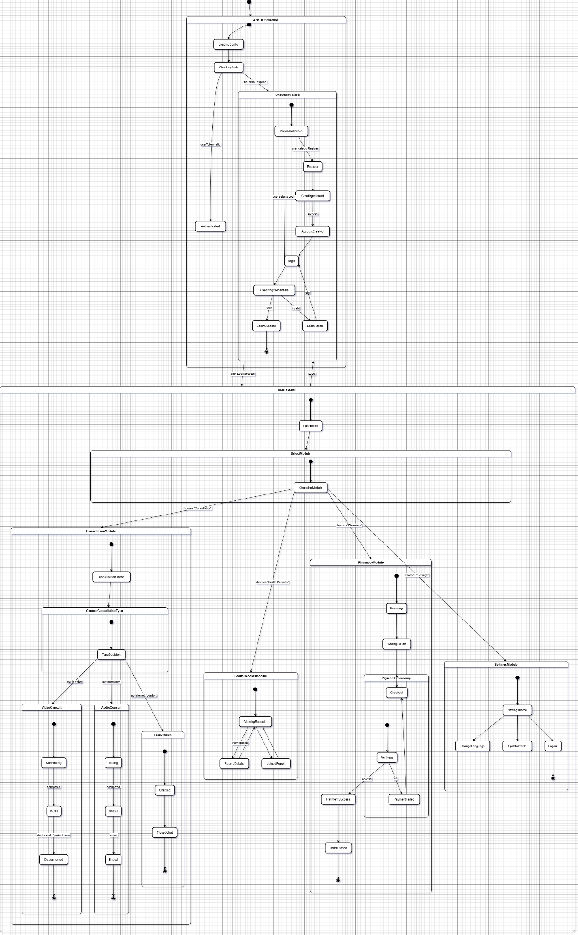

**Chapter 5:** Interaction Modeling

**5.1 Use case Diagram**

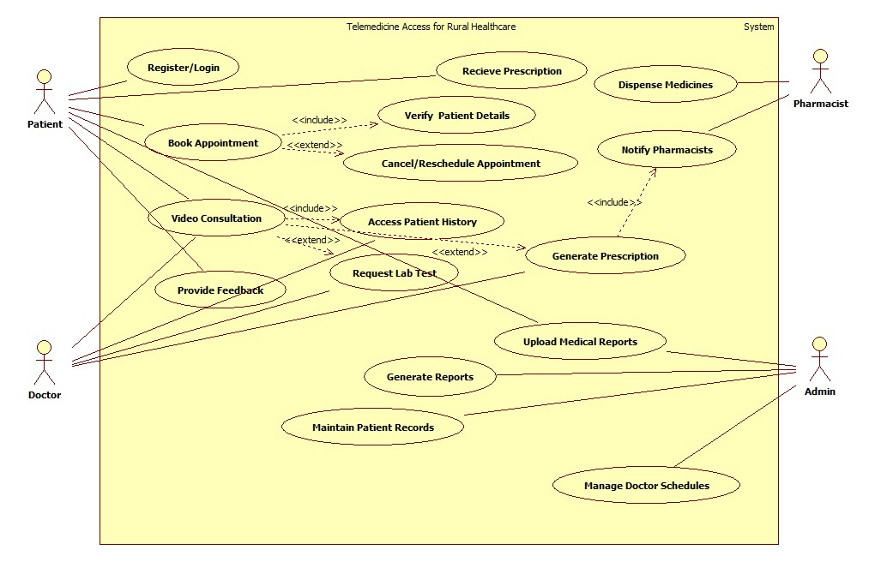

#### Actors and Their Roles

* Patient: The primary end-user seeking medical consultation.
* ASHA Worker: Acts as a digital facilitator for patients, bridging the technology gap.
* Doctor: Provides remote medical expertise via the platform.
* Admin: Manages system operations, users, and generates reports.
* System: Represents automated backend processes.

#### Key Use Cases and Functionality

* Register/Login (<<include>> Verify Patient Details): Secures system access and ensures accurate patient data entry.
* Book Appointment (<<extend>> Cancel/Reschedule): Manages the scheduling and modification of consultations.
* Video Consultation (<<include>> Access Patient History): Enables remote diagnosis with immediate access to patient records.
* Maintain Patient Records: Creates and updates digital health records for continuity of care.
* Update Medical Reports (<<extend>> Request Lab Test): Allows doctors to manage patient diagnostics and order tests.
* Generate Reports: Provides the Admin with insights into system usage and performance.

**5.2 Sequence Diagram**

The workflow is divided into three main phases:

**1. Authentication & Scheduling Phase:**  
The process begins with the Patient registering or logging into the system. The System verifies the credentials and upon successful authentication, allows the patient to book an appointment. The system checks Doctor Availability and confirms the Appointment Booked. This phase ensures only authorized users can schedule consultations.

**2. Consultation & Diagnosis Phase:**  
The patient can Upload Medical Reports, which the system confirms as Upload Successful. When the Doctor joins, they can Access Patient History to view the Display Records. The core interaction is the Video Consultation, initiated when the system connects both parties to a Consultation Session. Based on the diagnosis, the doctor may Request Lab Test (confirmed as Lab Test Requested) and Generate Prescription, making it Prescription Available.

**3. Prescription Fulfillment & Feedback Phase:**  
The system automatically Notify Pharmacist of the new prescription. The pharmacist can Show Prescription, Verify Prescription, and upon confirmation (Verified), Dispense Medicines. Finally, the patient can Provide Feedback, which is Feedback Recorded by the system, completing the telemedicine cycle and enabling continuous service improvement.

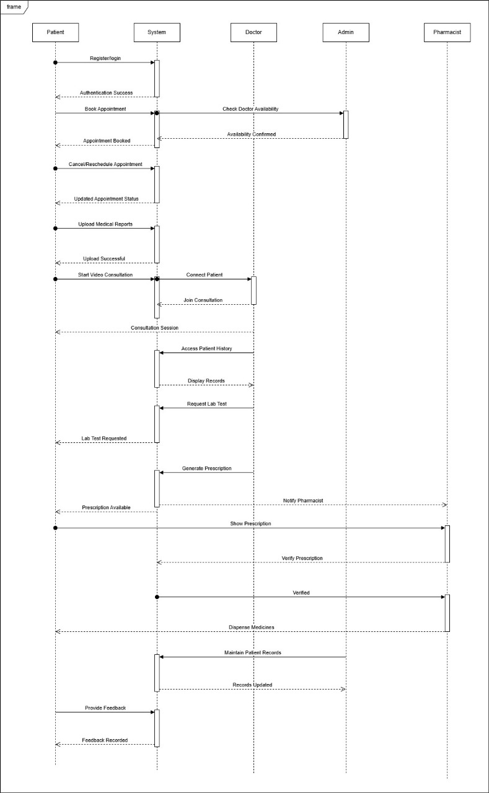

**5.3 Activity Diagram**

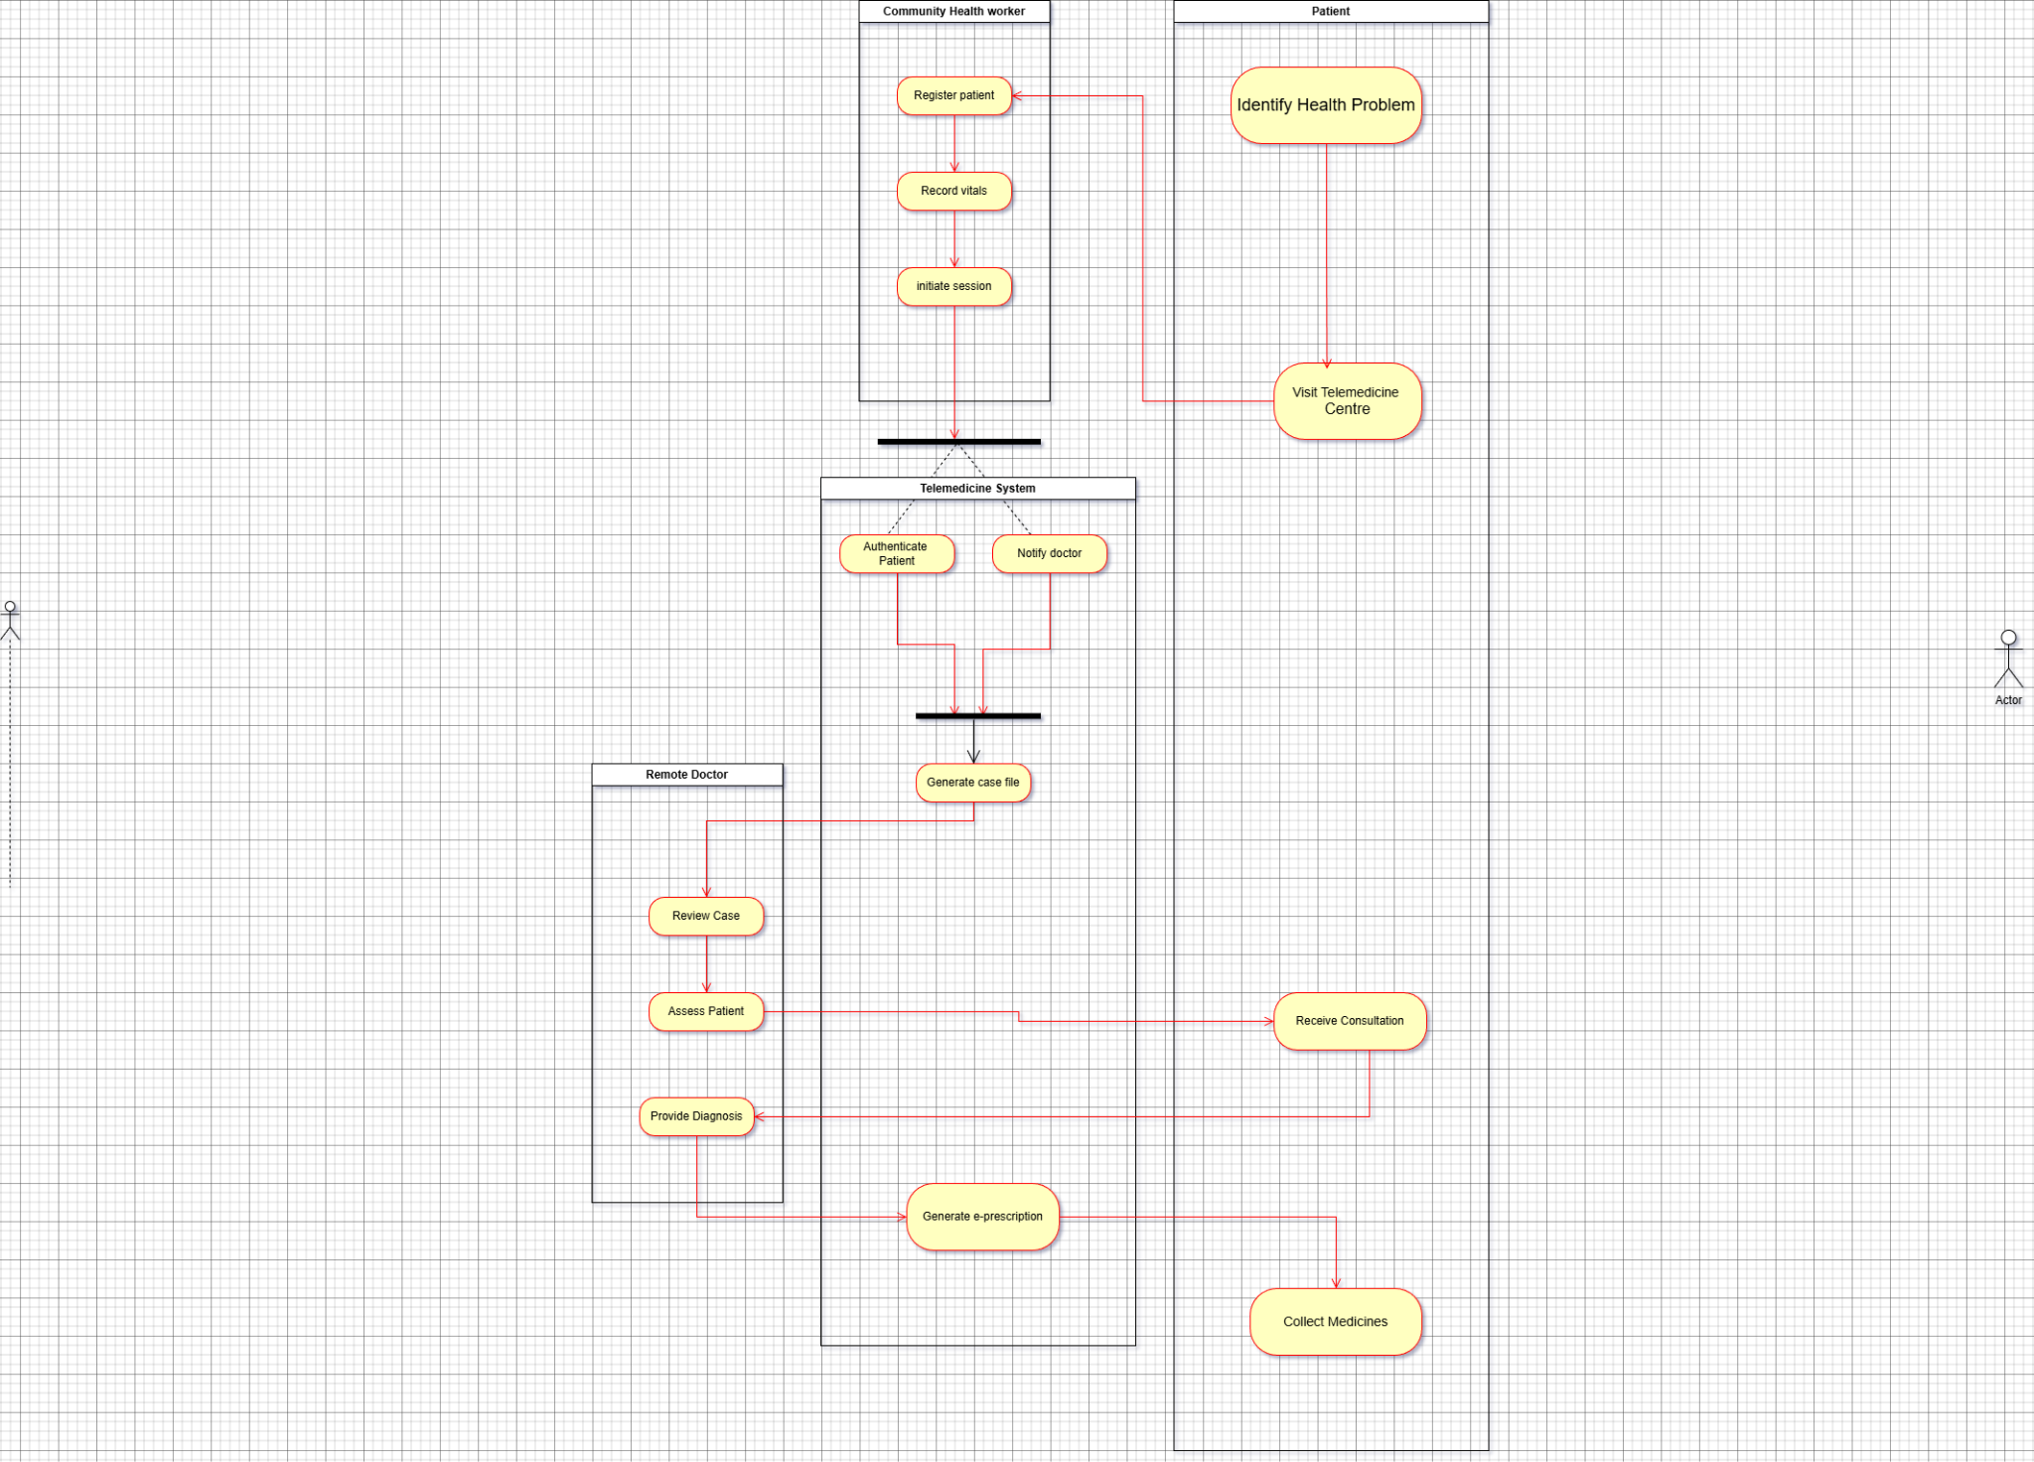

#### Swimlanes and Responsibilities

The diagram is organized into four swimlanes, each representing a different participant's responsibilities:

* Patient Swimlane: Initiates the process by feeling sick and visiting the telemedicine center, concluding by receiving medicines.
* Community Health Worker Swimlane: Handles the initial patient interaction including checking details, recording vitals, and initiating the telemedicine call.
* Telemedicine System Swimlane: Manages case creation and doctor notification as automated system functions.
* Doctor Swimlane: Performs medical duties including case review, patient consultation, and prescription generation.

#### Control Flow: Splitting and Merging

The diagram demonstrates key control flow patterns:

* Fork (Splitting): After the Community Health Worker "Start Telemedicine Call," the control splits into parallel paths:
  + One path goes to the Telemedicine System to "Create Case" and "Notify Doctor"
  + Another path goes directly to the Doctor for "Review Case"
* Join (Merging): The parallel paths converge before the "Consult Patient" activity, ensuring that both system preparation and doctor review are completed before the consultation begins.

The workflow progresses sequentially through patient intake, parallel processing of case setup and medical review, followed by consultation and prescription fulfillment, representing a complete telemedicine cycle.

**Chapter 6: UI Design with Screenshots**

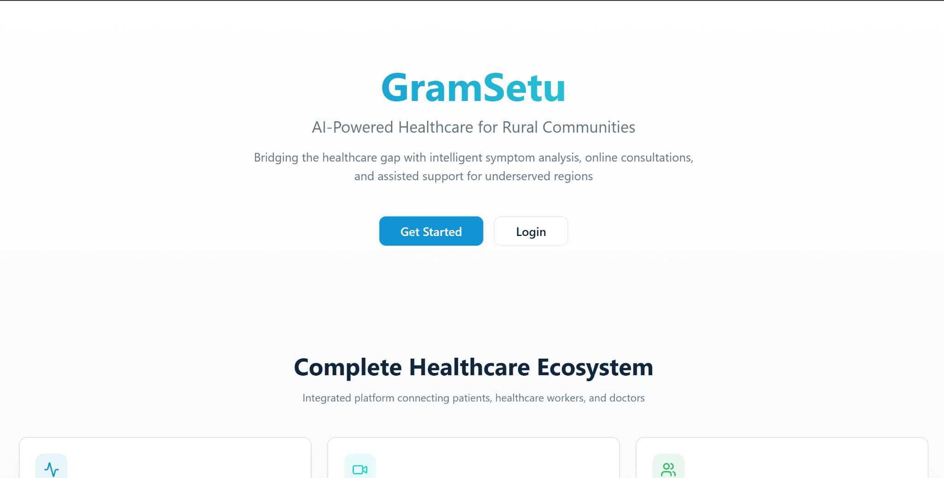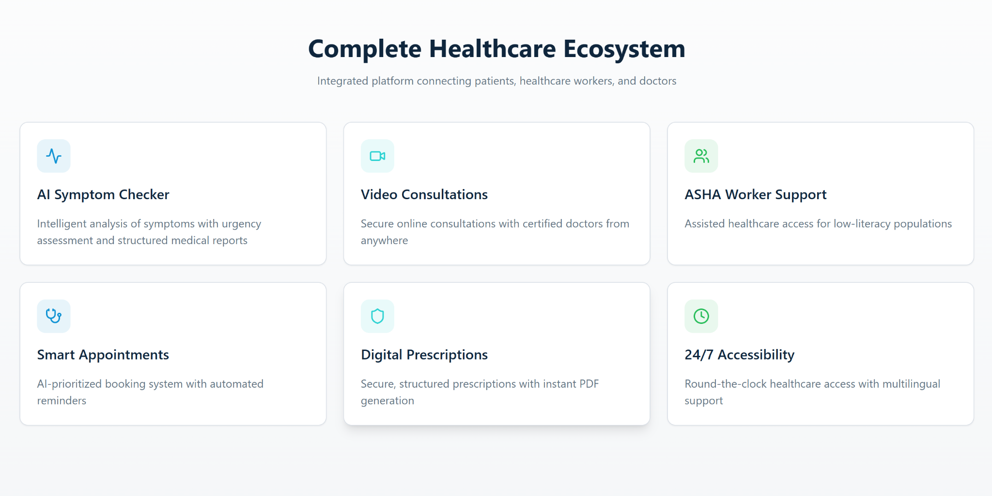

The platform features a **modern, minimal, and intuitive user interface**, designed to ensure smooth usage for patients, doctors, and ASHA workers. The UI follows a clean medical theme with calm colours, clear typography, and responsive layouts that work seamlessly across devices.

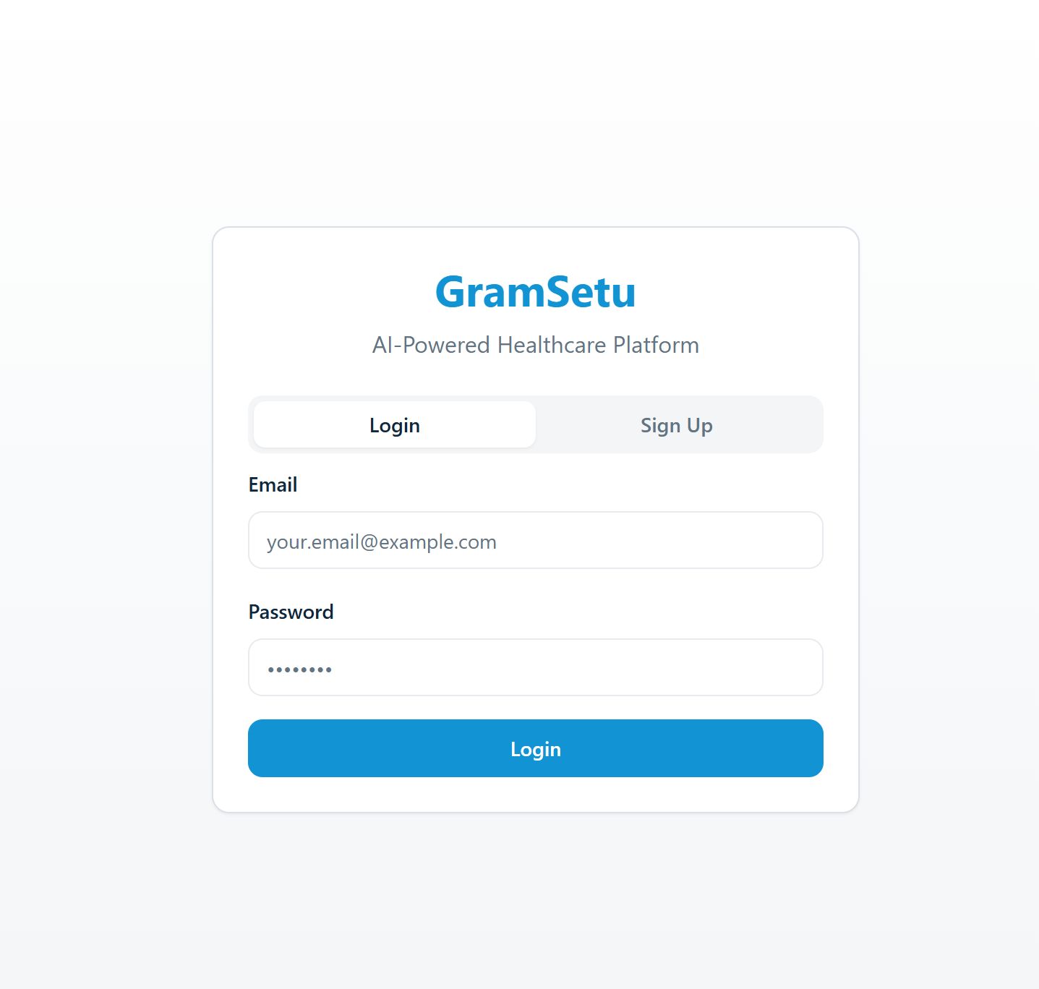

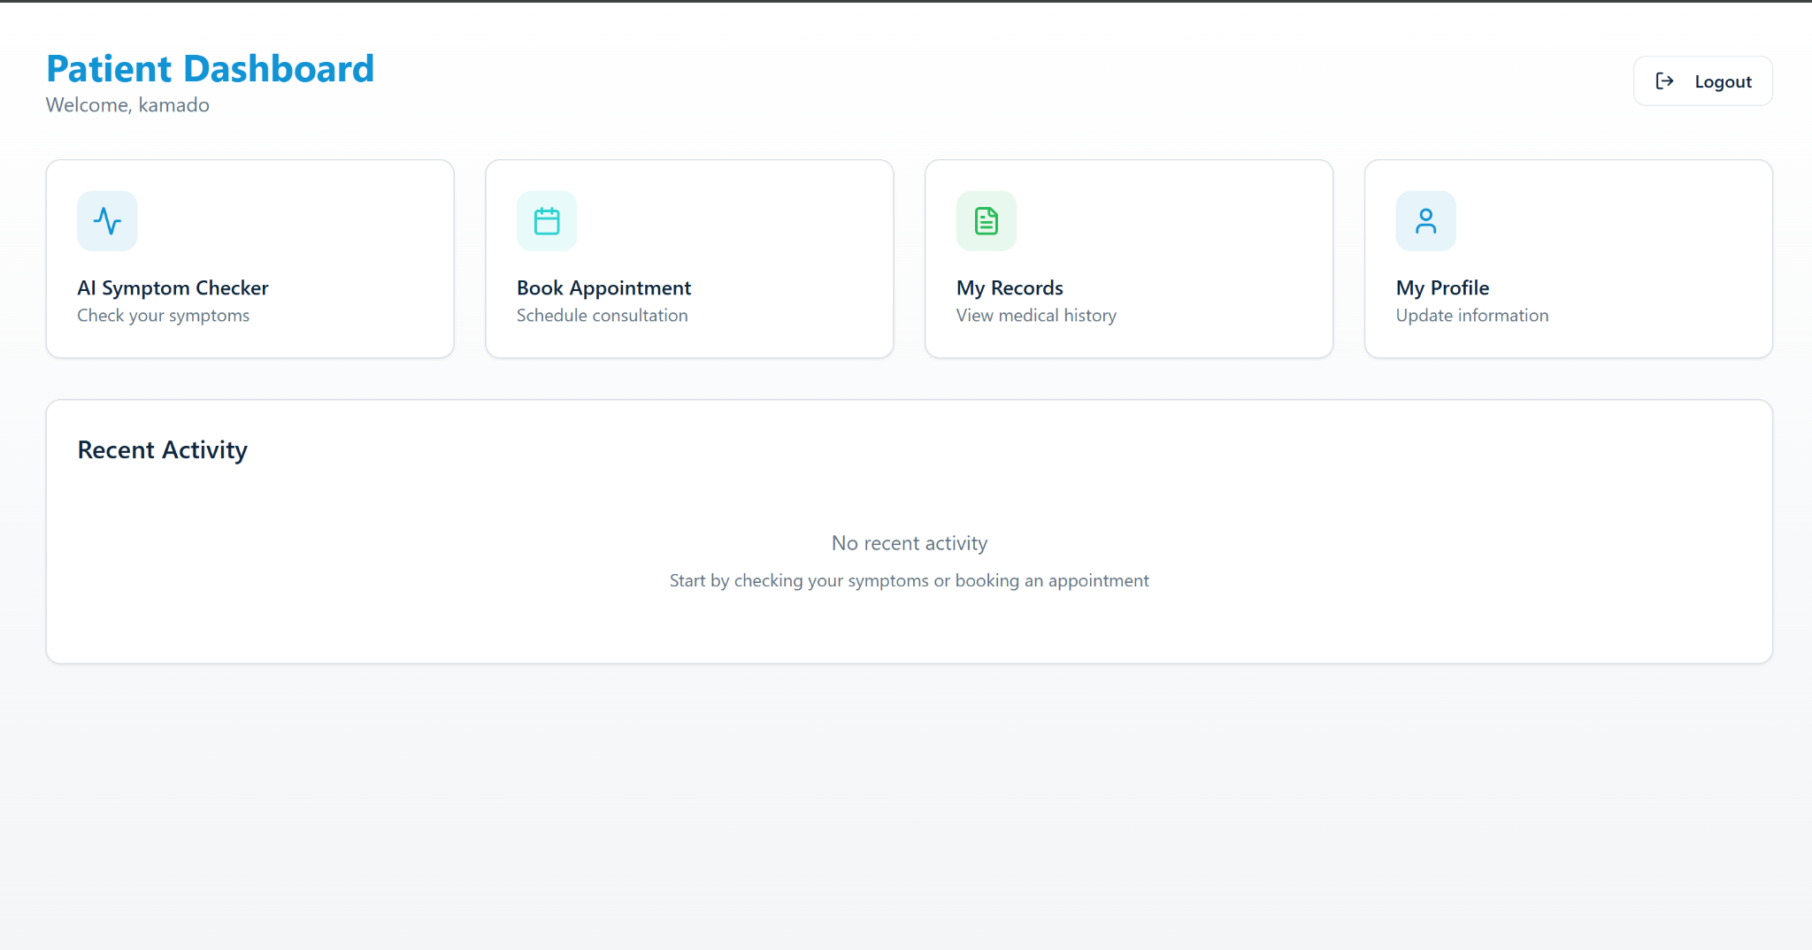

## 1. Patient Dashboard UI

The patient dashboard is designed for simplicity and comfort. It shows key options such as **AI symptom checker**, **book appointments**, **consultation history**, and **view prescriptions** in a clean card-based layout. Large icons, guided steps, and optional voice input make it easy for rural users and first-time digital users.

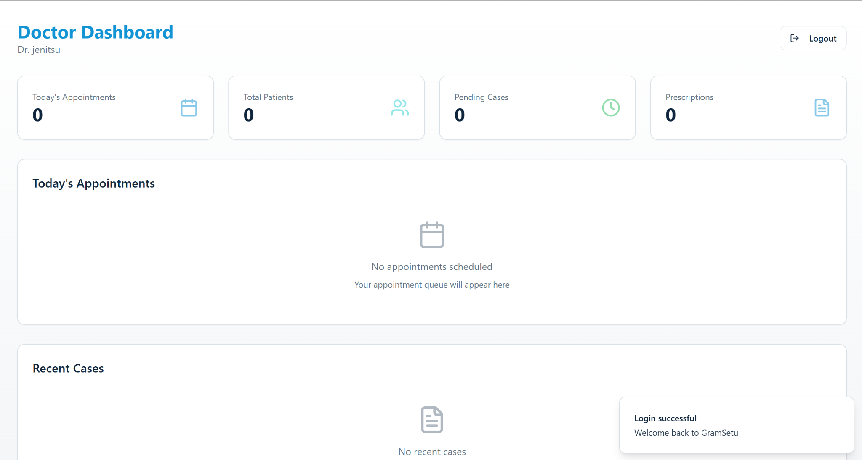

## 2. Doctor Dashboard UI

The doctor dashboard is built for efficiency, enabling doctors to quickly access **upcoming appointments**, **AI-generated patient summaries**, **medical records**, and **video consultation tools**. The interface focuses on clarity and speed, allowing doctors to handle more cases with better precision through structured data and organised navigation.

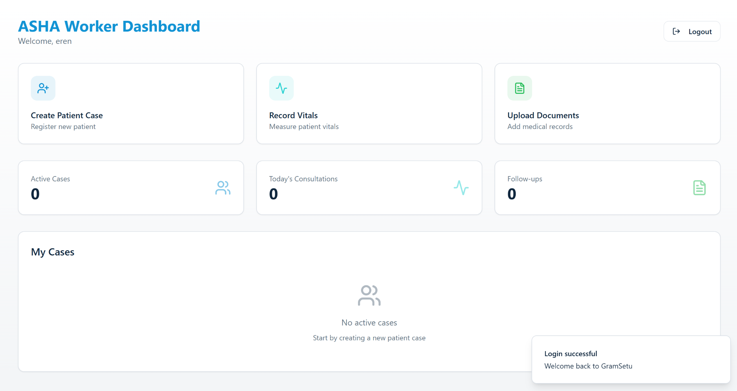

## 3. ASHA Worker Dashboard UI

The ASHA worker dashboard includes simple, high-visibility controls for **creating patient cases**, **recording vitals**, **booking appointments on behalf of patients**, and **uploading reports**. The interface is highly guided with step-by-step prompts, ensuring ease of use for field health workers with varying levels of digital experience.

## Overall UI Design

* **Clean, minimal, professional** medical theme
* **Responsive and mobile-first** for easy use in rural environments
* **Clear navigation and large touch-friendly components**
* **Focus on accessibility** with language support and voice features
* **Consistent layout across roles**, customised based on permissions